Dette er riktig kodebok ala 4.3 2024 😊

Anchoring & prompt:
On February 24th 2022, Russia initiated a large-scale military invasion of Ukraine. A group of researchers seeks to investigate how different Russian warbloggers, who post about the war on their Telegram channels, write about Vladimir Putin, the President of Russia. They gathered all posts that mention Putin. Imagine you are a political scientist with in-depth knowledge about Russia and have been hired to code the content of Telegram posts, utilizing your knowledge.
The warbloggers frequently refer to the war as a special operation. They hold anti-Western views, exhibit pro-Russian sentiments (though not necessarily unconditional support for the Russian government), and generally endorse the ongoing war.
The Telegram post reads: “X”. Your task is to answer the following questions. Answer based on explicit clues in the post.

FOCUS QUESTIONS
War_mention: Does the post mention the war in Ukraine? 0 (no), 1 (yes).
Putin_focus: All the post mention Putin, but not all posts are about Putin mainly. Is Putin the main focus of this post? 0 (no), 1 (yes).
Post_type: What kind of post is this? (0) news/quote/factual description, (1) opinion/commentary.

MAIN QUESTIONS
Vibe_Putin: Does the post appear to be supportive or opposed to Putin? 1 (opposed), 2 (neither opposed or supportive), 3 (supportive).
Support_Putin: Does the author of the post express personal support for Putin? 0 (no), 1 (yes).
Criticism_Putin: Does the author of the post explicitly criticize Putin? 0 (no), 1 (yes).

April:
- Code 200 posts
- Agree on the posts we disagreed on
- Go over ChatGPT and see if we agree on it
- Make validation based on this

Vibe_Putin: Does the post appear to be supportive or opposed to Putin? 1 (opposed), 2 (neither opposed or supportive), 3 (supportive).

- What are they saying (context – is it good) vs. Is the purpose of the post to frame Putin in a good light.
- What is the point of having a “vibe” variable if we are not including context?

POST | 2 NEITHER OPPOSED OR SUPPORTIVE | 3 SUPPORTIVE
"Putin held a meeting at the headquarters of the Southern Military District in Rostov-on-Don.  The President listened to reports from the Chief of the General Staff of the Russian Armed Forces Valery Gerasimov, commanders of directions, and other senior officers of the group.  🟩 Subscribe - RT in Russian" | - No positive framing (e.g. “positive reports”). | Why it’s supportive:  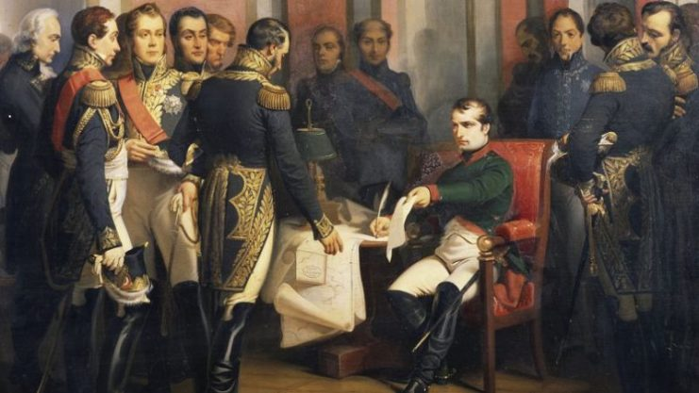  - Context, association, image
_Peskov: Putin's meeting with Erdogan is already being prepared, there is an understanding that it will take place soon.  🟩 Subscribe - RT in Russian  _Putin does not plan to attend the G20 summit in India, which will take place in September, Peskov said, noting that the main focus now is on the special military operation.  🟩 Subscribe - RT in Russian. |  | -”The main focus is the military operation” is a positive explanation for why he is not going  -This could be seen as an attempt to change the narrative that he is not going because he is not welcomed, in other words an attempt to defend Putin. It is very reasonable that such an attempt/explanation stem from support toward Putin  -A completely neutral post would rather just inform that he is not going, rather than giving an explanation in favor of Putin.

